LINUX SYSTEM ADMINISTRATION
To Identify the current shell and length of the string
Program 1
#!/bin/bash
echo "To Identify the current shell and length of the string"
echo "The current shell is = $SHELL"
str1="welcome to Rathinam college"
echo $str1
len=${#str1}
echo "length of the string = $len"
OUTPUT
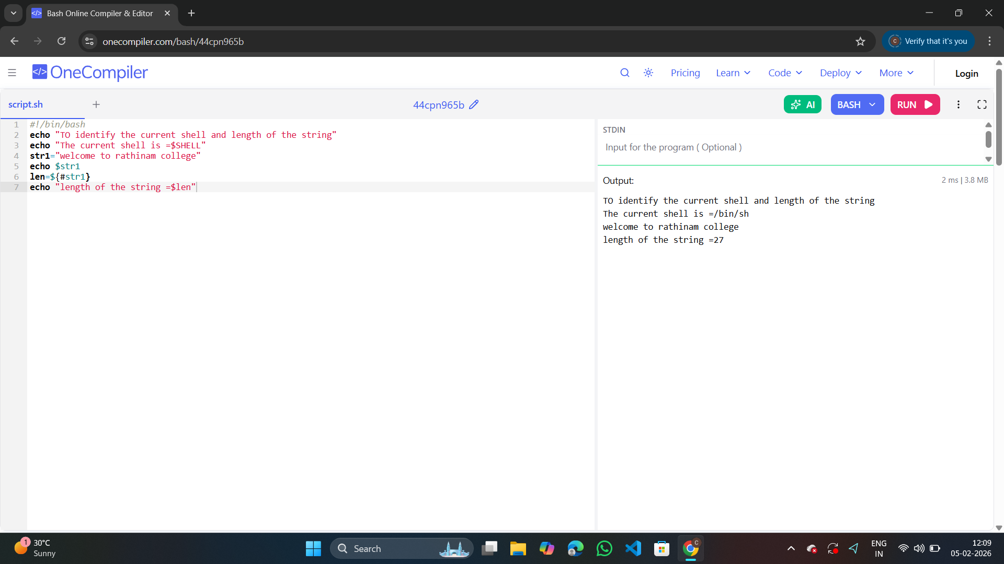

Program 2
#!/bin/bash
echo "To connect Backwords for 180 to 0 using for loop"
c=0
for((i=100;i>=0;--i))
do
echo "$i"
s=$[c++]
done
echo "______________"
echo "count =$s"
echo "______________"

OUTPUT

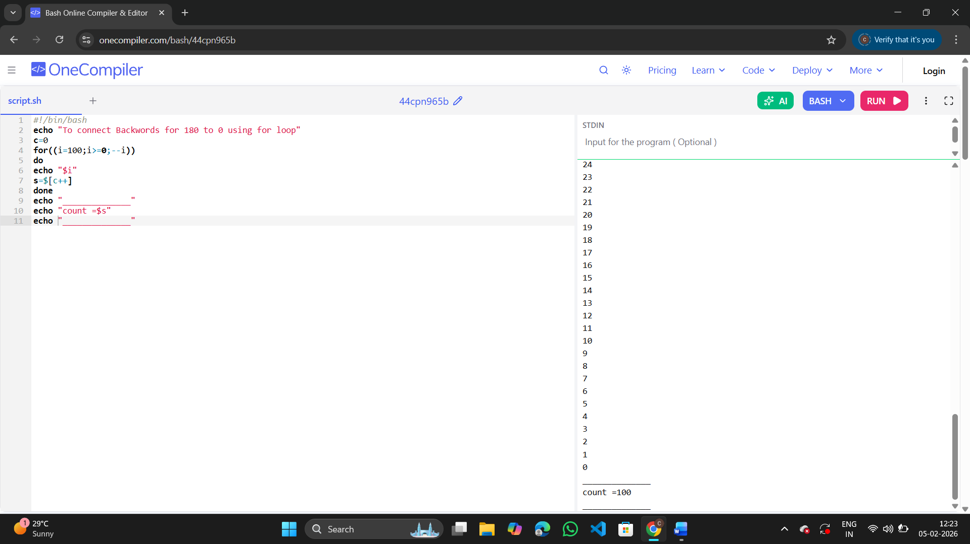

Program 3
echo "........................................."
echo "To print the star in the descending order"
echo "........................................."
for ((i=5; i>=1; i--))
do
for ((j=1; j<=i; j++))
do
echo -n "*"
done
echo
done
echo ".........................................."

OUTPUT
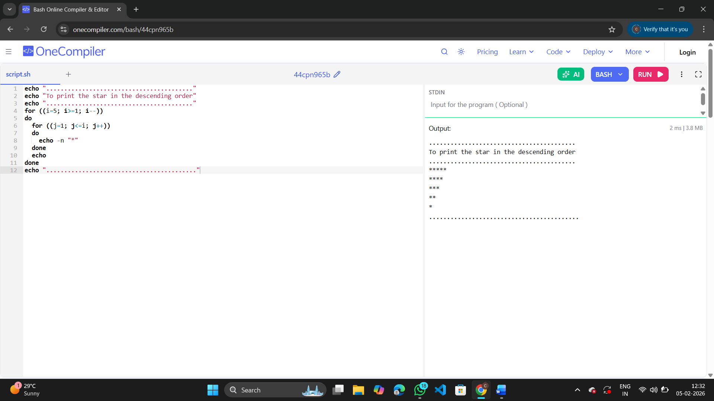

Program 4
#!/bin/bash
echo "To print the odd and even numbers and their sum and count from 0 to 100"
even_count=0
odd_count=0
even_sum=0
odd_sum=0

echo "Even numbers from 0 to 100:"
for (( i=0; i<=100; i++ ))
do
if (( i % 2 == 0 )); then
echo -n "$i "
((even_count++))
((even_sum+=i))
fi
done

echo -e "\n\nOdd numbers from 0 to 100:"
for (( i=0; i<=100; i++ ))
do
if (( i % 2 != 0 )); then
echo -n "$i "
((odd_count++))
((odd_sum+=i))
fi
done

echo -e "\n\n--- Summary ---"
echo "Even numbers count = $even_count"
echo "Even numbers sum = $even_sum"
echo "Odd numbers count = $odd_count"
echo "Odd numbers sum = $odd_sum"

OUTPUT
